**Integration Runtime for two linked Services:**

**Create a shared self-hosted IR using Azure Data Factory UI**

**To create a shared self-hosted IR using Azure Data Factory UI, you can take following steps:**

1. **In the self-hosted IR to be shared, select Grant permission to another Data factory and in the "Integration runtime setup" page, select the Data factory in which you want to create the linked IR.**

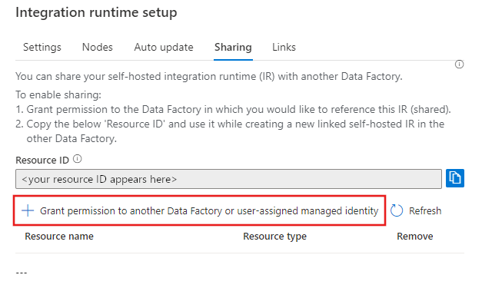

1. **Note and copy the above "Resource ID" of the self-hosted IR to be shared.**
2. **In the data factory to which the permissions were granted, create a new self-hosted IR (linked) and enter the resource ID.**

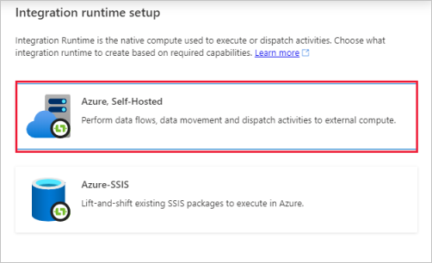

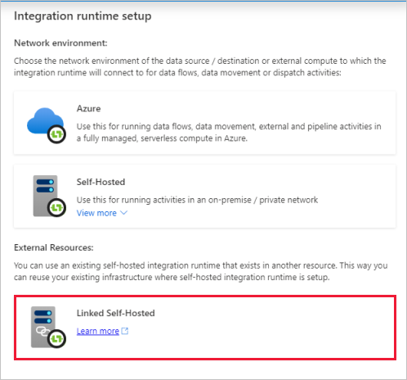

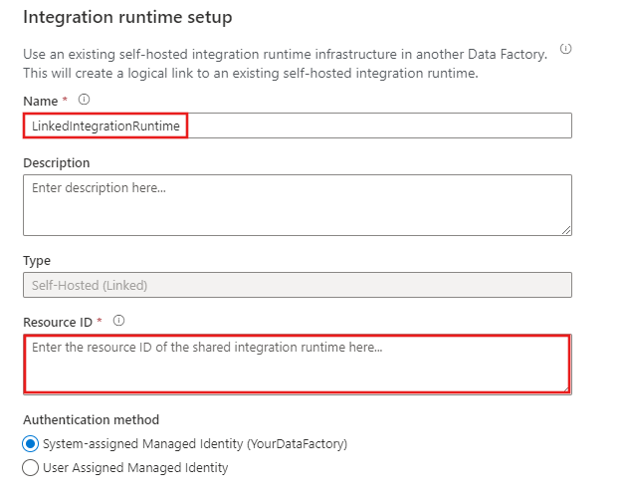

**EXPLANATION:**

Here when I created an SHIR1 for practice-02 df; I used the authentication that I got when I am creating a linked service in this data factory; let us assume this as key1 I am unable to use the SHIR1 in another data factory for my project Bcase01-df when I am creating linked service in this data factory; so here

I tried various methods like : DNS resolution to see if the data factory is connecting to linked service in a right way or not; this has not worked

So I removed everything and reinstalled everything(WHICH IS A BAD PRACTICE)

I created a integration runtime for Bcase01-df🡺 linked service 🡪 let us assume I created SHIR2 the key I used is key2

Again I want to use this in practice02-df linked service to see if it works and it is not working

I Observed that the authentication keys are different for two data factories even if I selected same SHIR2

So that’s when I followed above process in which I used the same integration runtime SHIR2 for both data factories.

PROCESS:

**1. Grant Permissions in the Source Data Factory:**

* **Navigate to the Source Data Factory** (the Data Factory that owns the self-hosted integration runtime🡺NAME OF INTEGRATION RUNTIME: integrationRuntime1).
* Go to **Manage** → **Integration Runtimes**.
* Find the self-hosted IR (integrationRuntime1), and select **Edit**.
* Under the **Integration Runtime setup** page, go to the **Sharing tab**.
* Make sure you have selected **Grant permission to another Data Factory** and provide the necessary permissions to the target Data Factory.(Here we are granting permission to the Managed identity(which means service of azure i.e. data factory) but we are not selecting the user identity.
* Copy the **Resource ID** of the integration runtime to use in the next step.

**2. Create Linked IR in the Target Data Factory:**

* **Navigate to the Target Data Factory** (the Data Factory that is trying to use the shared IR).
* Go to **Manage** → **Integration Runtimes**.
* Click on **New** and select **Self-hosted**.
* In the **Self-hosted IR setup** page, choose **Create linked IR** and paste the **Resource ID** from the source Data Factory’s IR.
* Provide a name for the linked IR and click **Create**.

**3. Ensure Proper Permissions:**

* Make sure that the Data Factory in the source environment has **sufficient permissions** to share the IR with the target Data Factory. It needs the **Owner** or **Contributor** role on the source Data Factory for the IR to be accessible.
* The target Data Factory also needs appropriate permissions to **link to** the shared IR.

**4. Check Identity and Access Control:**

* If you're using managed identities (either **system-assigned** or **user-assigned**), ensure that the correct identities have been granted the necessary permissions.
* If the IR is using a **user-assigned managed identity**, make sure it is properly configured in both the source and target Data Factory.

After following these steps, try again to create the linked IR in the target Data Factory.

So I copied the ResourceID of integration runtime that is running in Bcase01-df and pasted it in target DF (by creating a new integration runtime in practice02-df as Azure, self-hosted).

This way I linked the same integration runtime to two different data factories:

Bcase01-df Integration runtime:

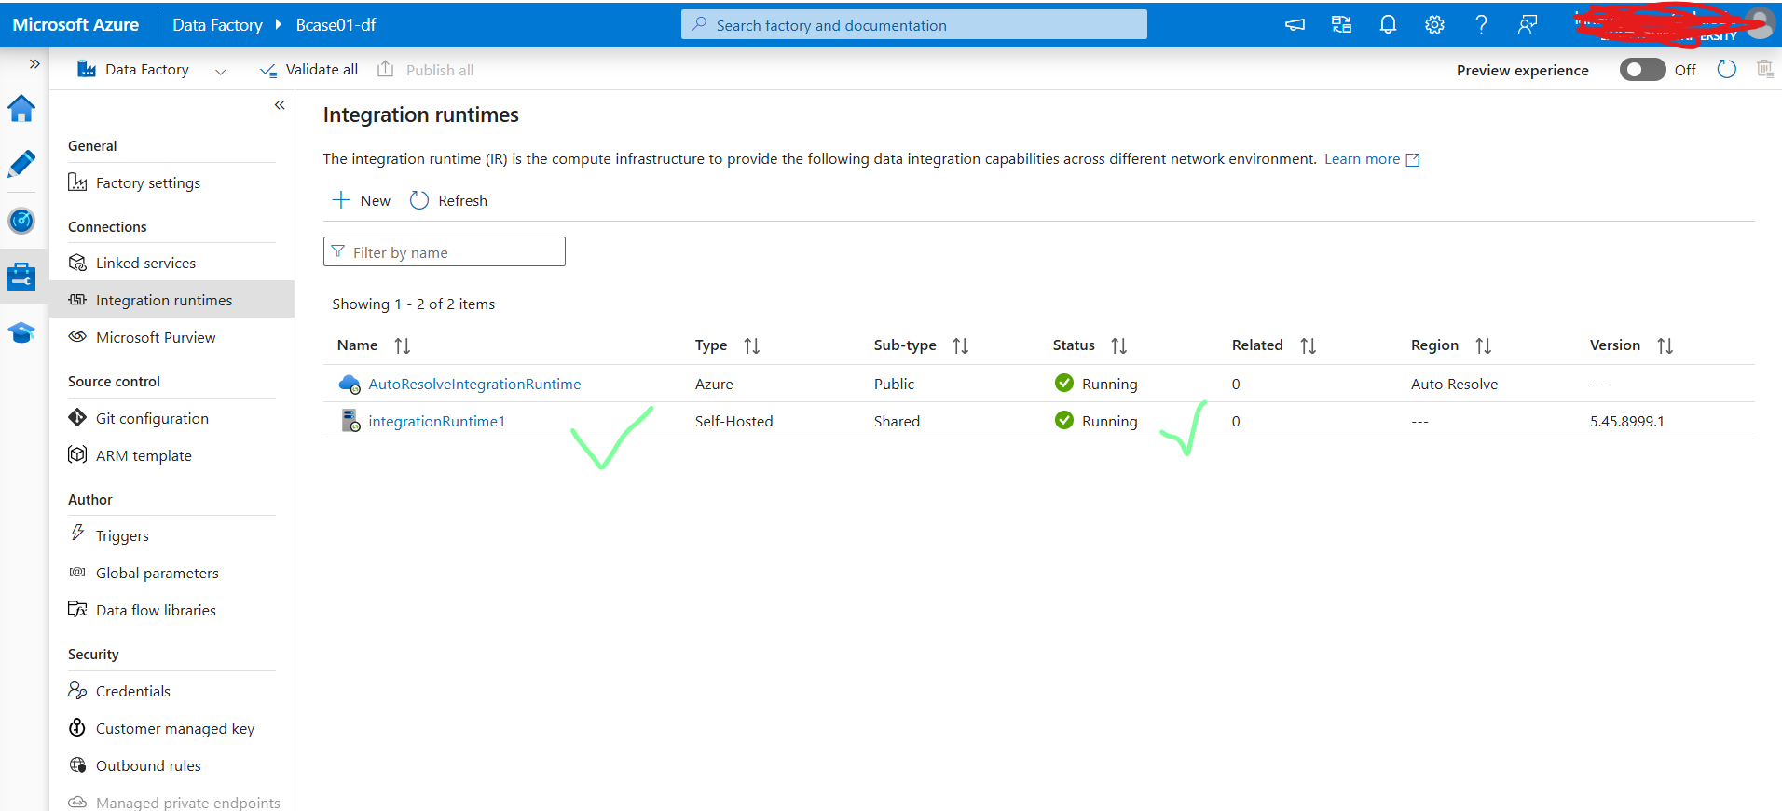

Practice02-df

